Project Design Phase-II
Data Flow Diagram & User Stories

Date | 31 January 2025
Team ID | SWTID-2026-2491
Project Name | AI BlogNest API
Maximum Marks | 4 Marks

Data Flow Diagrams:
A Data Flow Diagram (DFD) visually represents how information moves through the AI BlogNest API. It shows how a user or application submits a blog topic and writing preferences, how the API validates and processes the request, how an AI service generates content, and how the draft is returned or stored. A clear DFD helps stakeholders understand the API’s data inputs, processes, outputs, and storage.

Example: (Simplified)

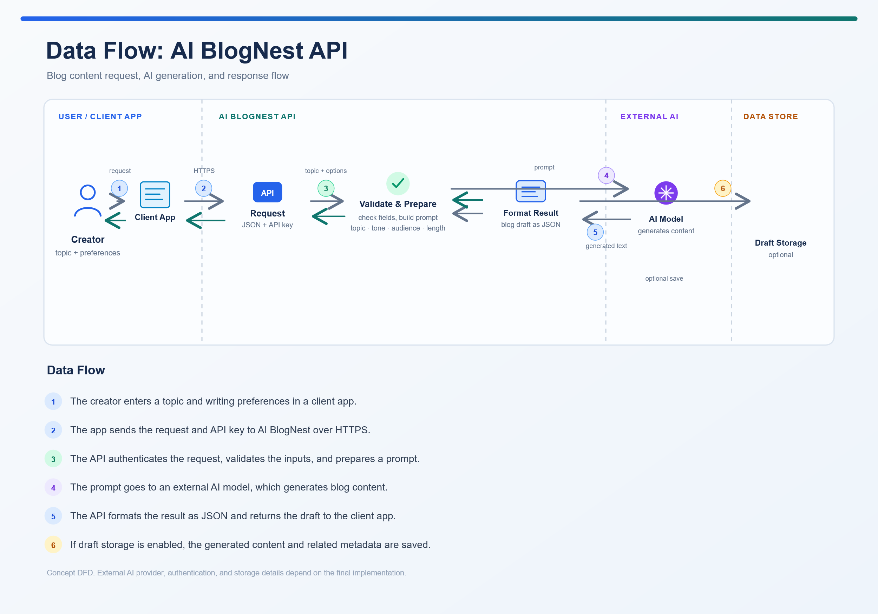

User Stories

User Type | Functional Requirement (Epic) | User Story Number | User Story / Task | Acceptance Criteria | Priority | Release
Developer / API Consumer | API Request | USN-1 | As a developer, I can submit a blog topic and writing preferences to the API so my application can request content. | A valid request is accepted and returns a request or generation status. | High | Sprint-1
Developer / API Consumer | API Authentication | USN-2 | As a developer, I can authenticate API requests with an API key so only authorized applications can use the service. | A valid key is accepted; a missing or invalid key returns an authentication error. | High | Sprint-1
Developer / API Consumer | Request Validation | USN-3 | As a developer, I receive clear feedback when required request fields are missing or invalid. | The API identifies invalid fields and returns a readable validation error. | High | Sprint-1
Content Creator | Blog Generation | USN-4 | As a content creator, I can generate an outline from a topic so I can organize my ideas before drafting | The API returns an outline related to the submitted topic. | High | Sprint-2
Content Creator | Blog Generation | USN-5 | As a content creator, I can generate a complete blog draft so I can create content more quickly. | The API returns a draft with a title, introduction, body sections, and conclusion. | High | Sprint-2
Content Creator | Content Customization | USN-6 | As a content creator, I can choose the tone, audience, language, and length so the draft suits my needs. | The generated draft reflects the valid preferences included in the request | High | Sprint-2
Developer / API Consumer | API Response | USN-7 | As a developer, I receive generated content in a consistent JSON format so my application can display it reliably. | The response follows the documented JSON structure and includes the generated content and status. | High | Sprint-2
Developer / API Consumer | Error Handling | USN-8 | As a developer, I receive clear error responses when a request is invalid or generation fails. | Errors include an appropriate status and a message that explains the problem. | High | Sprint-3
Content Creator | Draft Management | USN-9 | As a content creator, I can save and retrieve generated drafts so I can review and edit them later. | A saved draft can be retrieved by its identifier with its content intact. | Medium | Sprint-3
Administrator | API Documentation | USN-10 | As an administrator, I can provide API documentation and example requests so developers can integrate AI BlogNest | Documentation explains authentication, request fields, response format, and common errors, with usable examples. | High | Sprint-3

